Monitoring & Incident Response Plan
Enhancing Security in Messaging Applications
Spinnaker Analytics
29 June 2026

Table of Contents
- Introduction
- Security Monitoring Architecture
- Security Event Logging
- Threat Detection & Monitoring
- Incident Response Framework
- Incident Handling Procedures
- Security Monitoring Validation
- Security Governance & Reporting
- Standards Alignment
- Conclusion

1. Introduction

1.1 Purpose
- This document defines the monitoring, detection, alerting, and incident response procedures implemented to protect the messaging application against cyber threats and operational security incidents.
- The objective is to ensure timely identification, analysis, containment, eradication, and recovery from security events while maintaining the confidentiality, integrity, and availability of messaging services.

1.2 Objectives
- Continuous security monitoring
- Early threat detection
- Centralized log collection
- Incident response procedures
- Alert management
- Security reporting
- Continuous improvement

2. Security Monitoring Architecture
The monitoring solution collects logs from client applications, messaging servers, operating systems, network devices, and security tools.

2.1 Security Monitoring Architecture
Figure 31 – Security Monitoring Architecture
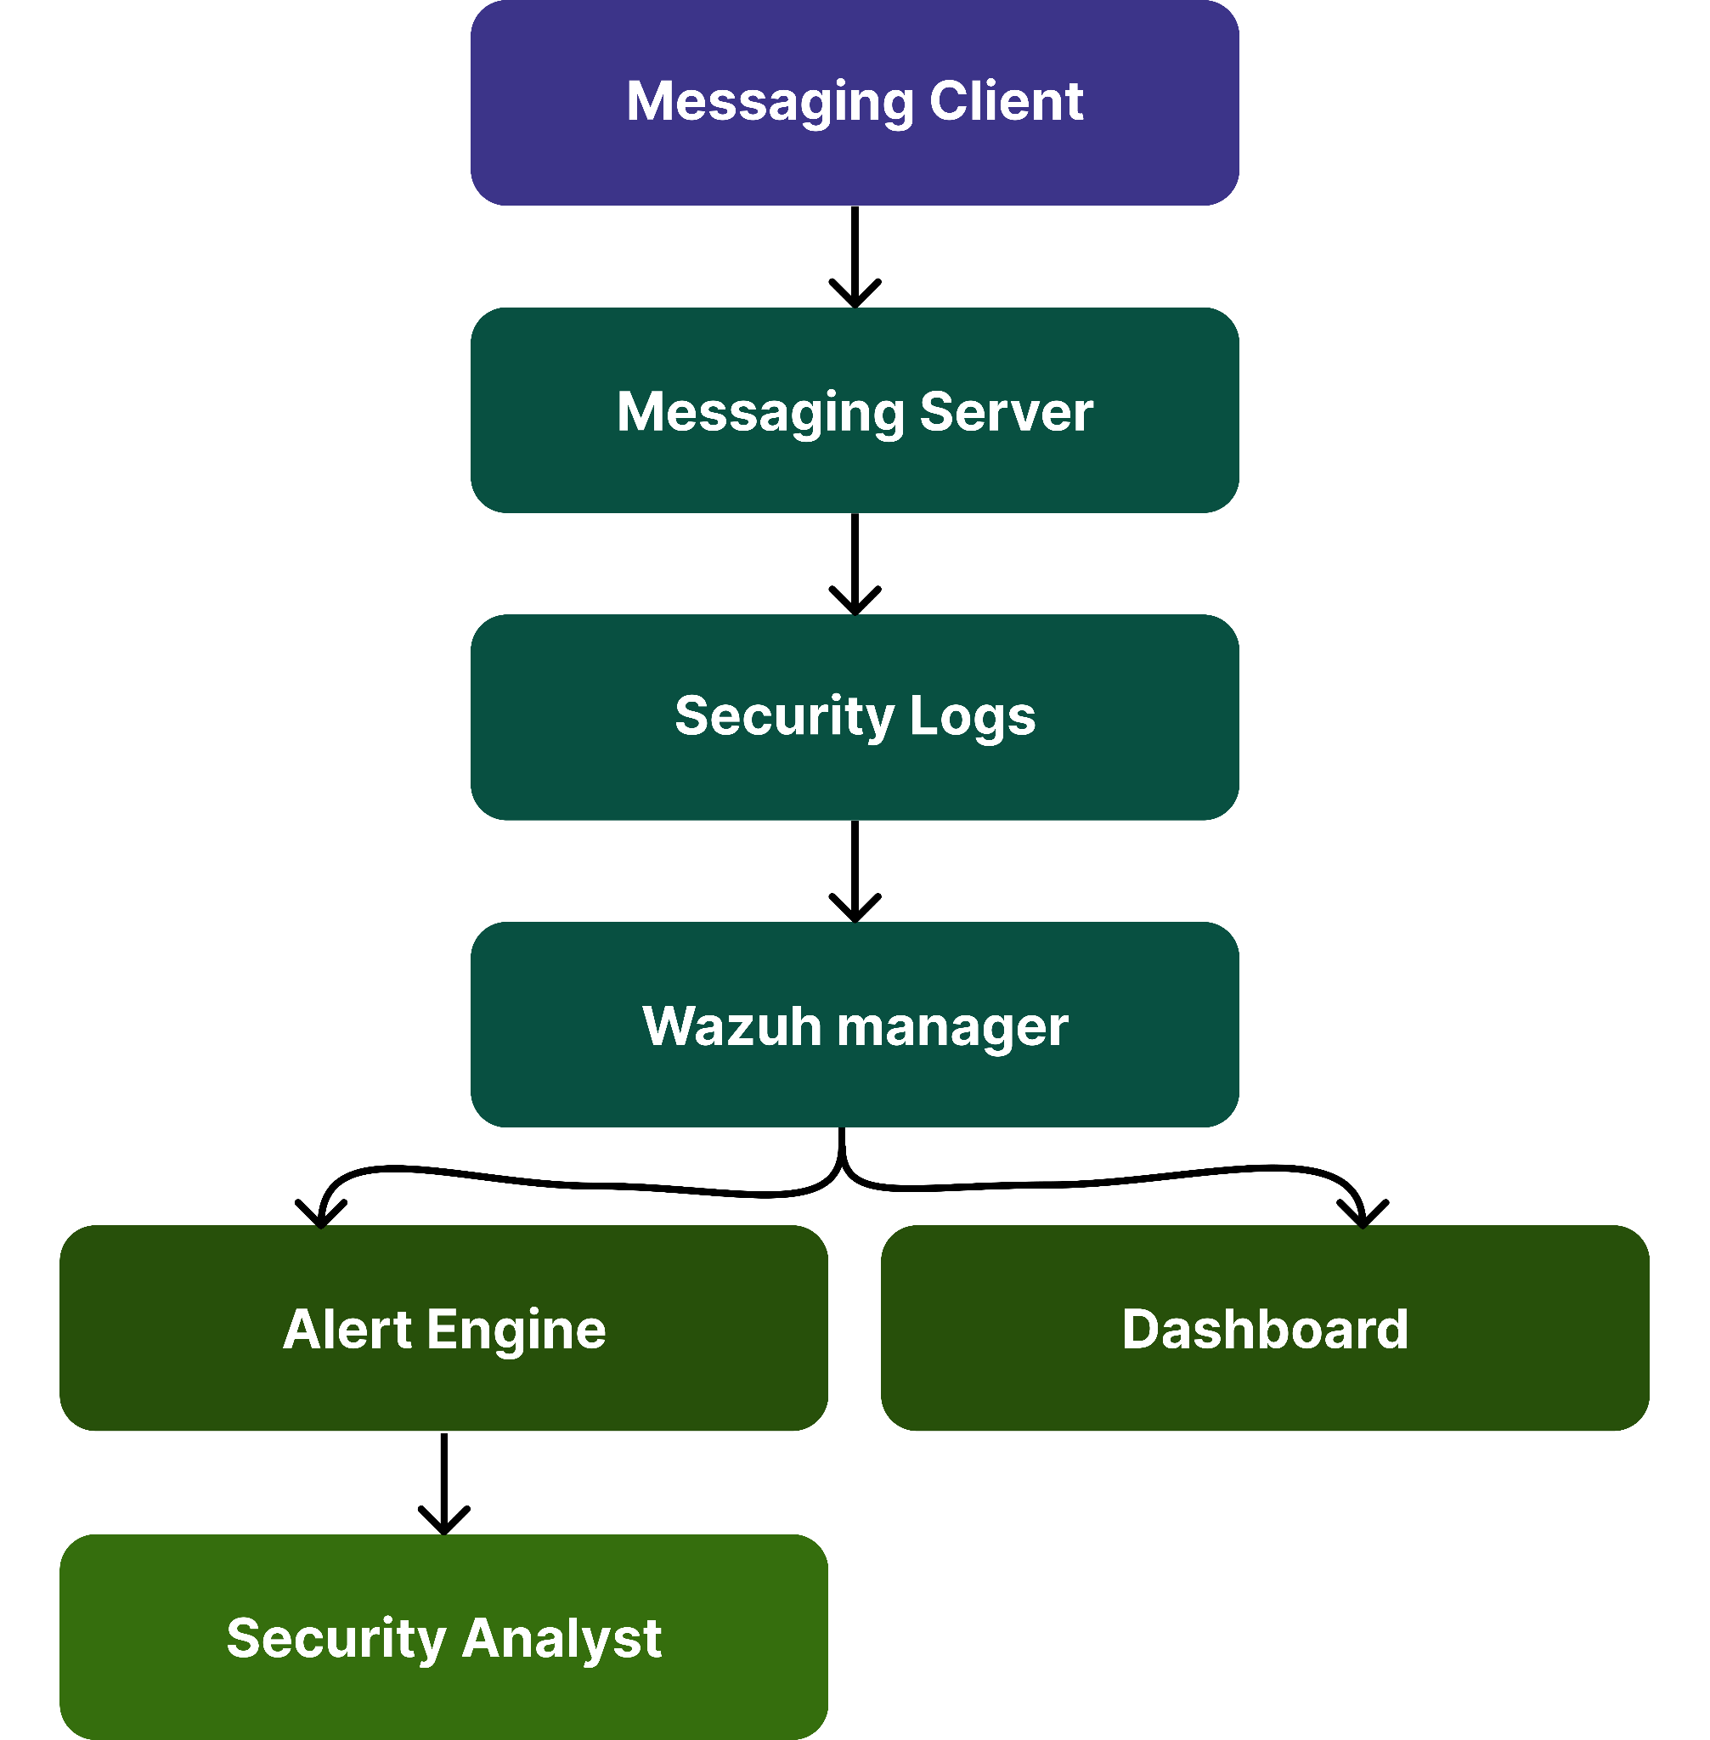

2.2 Monitoring Components
Component | Purpose
Wazuh Manager | Central log collection
Wazuh Agent | Endpoint monitoring
Suricata IDS/IPS | Network threat detection
OpenSearch Dashboard | Log visualization
OpenVAS | Vulnerability assessment

3. Security Event Logging

3.1 Logged Events
Event | Logged
User Login | Yes
Failed Login | Yes
Password Reset | Yes
MFA Failure | Yes
File Upload | Yes
Voice Call Initiation | Yes
Administrative Actions | Yes
Security Configuration Changes | Yes

3.2 Log Retention
Log Type | Retention
Authentication Logs | 90 Days
Application Logs | 180 Days
Security Alerts | 1 Year
Incident Reports | 1 Year

3.3 Log Collection
Figure 32 – Log Collection Workflow
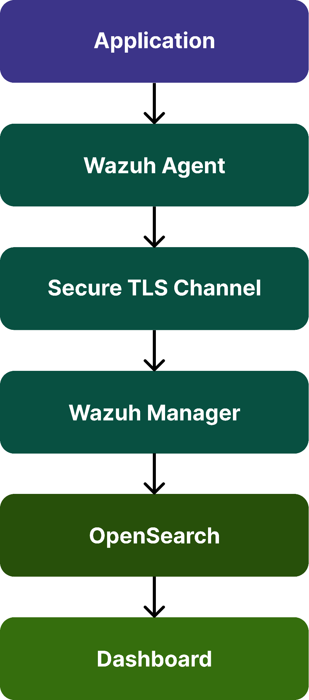

4. Threat Detection & Monitoring

4.1 Detection Sources
Source | Threat Detected
Wazuh | Host-based events
Suricata | Network attacks
OpenVAS | Vulnerability exposure
System Logs | Authentication anomalies
Application Logs | Unauthorized activity

4.2 Alert Severity Levels

Severity | Response
Critical | Immediate response
High | Within 1 Hour
Medium | Within 4 Hours
Low | Next business day

4.3 Threat Detection
Figure 33 – Threat Detection Workflow
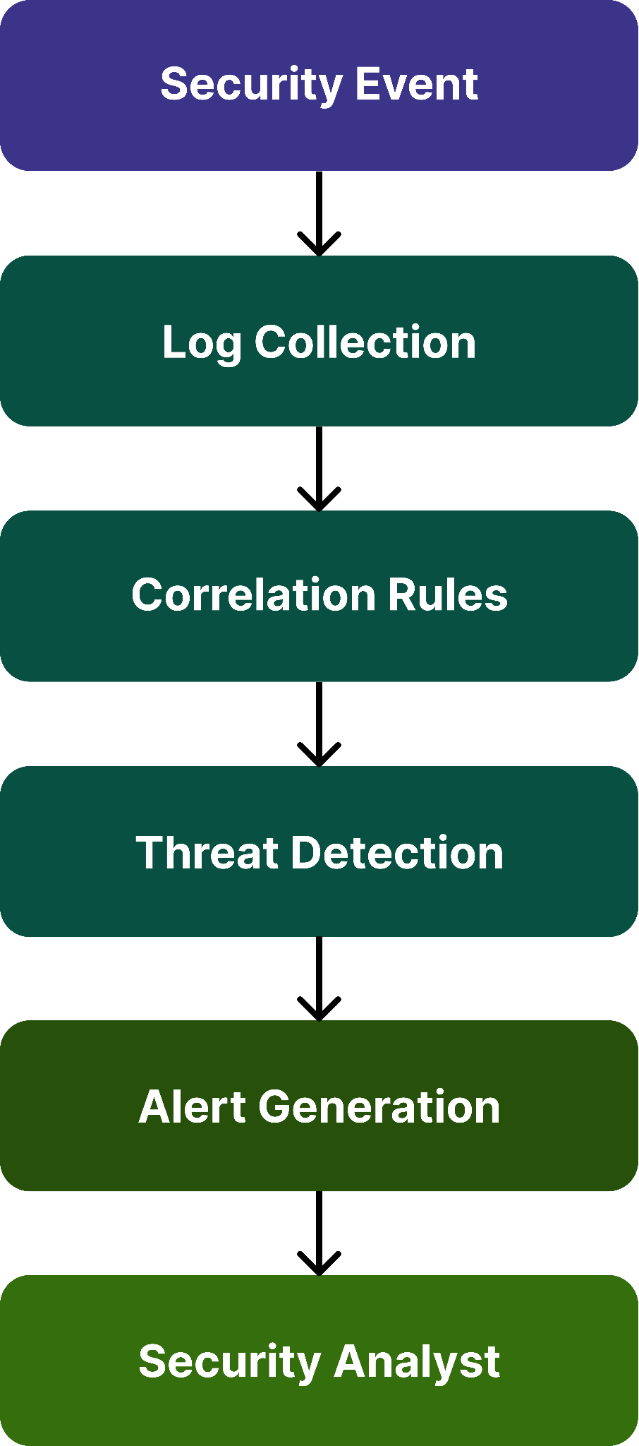

5. Incident Response Framework
The incident response process follows the NIST SP 800-61 Rev. 2 lifecycle.

5.1 Incident Response
Figure 34 – Incident Response Lifecycle
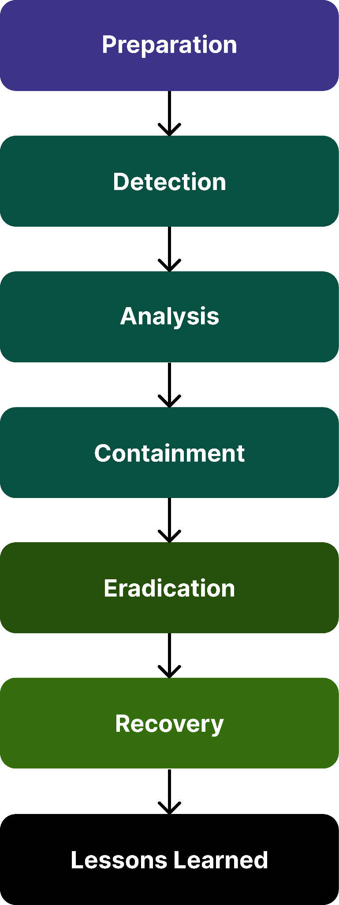

5.1 Incident Categories
Category | Example
Authentication | Brute-force login
Malware | Infected endpoint
Data Leakage | Unauthorized disclosure
Network Attack | DoS / Scanning
Insider Threat | Unauthorized administrative activity

5.3 Escalation Matrix
Severity | Escalated To | Response Time
Critical | SOC Manager | Immediate
High | Security Analyst | 1 Hour
Medium | System Administrator | 4 Hours
Low | IT Operations | Next Business Day

6. Incident Handling Procedures

6.1 Incident Workflow
- Step 1 – Detection
  - Alert generated
  - Incident ticket created
- Step 2 – Analysis
  - Validate alert
  - Determine severity
- Assess impact
  - Step 3 – Containment
  - Isolate affected systems
  - Block malicious IPs
  - Disable compromised accounts
- Step 4 – Eradication
  - Remove malicious artifacts
  - Patch vulnerabilities
  - Reset credentials
- Step 5 – Recovery
  - Restore services
  - Verify system integrity
  - Resume operations
- Step 6 – Post-Incident Review
  - Root cause analysis
  - Lessons learned
  - Update security controls

6.2 Incident Classification
Incident Type | Priority
Data Breach | Critical
Malware Infection | High
Unauthorized Login | High
Configuration Error | Medium
Failed Login Attempts | Low

6.3 Incident Handling
Figure 35 – Incident Handling Workflow
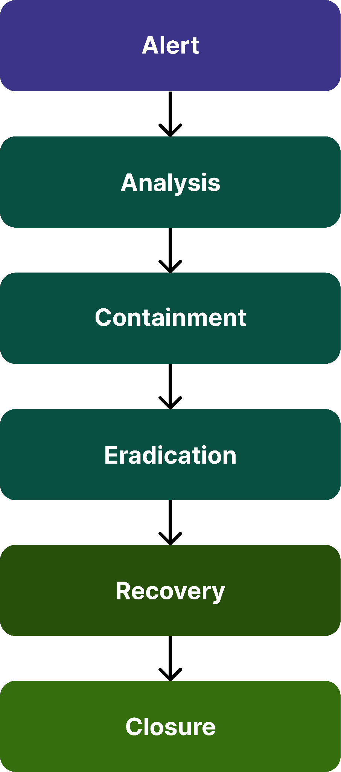

7.Security Monitoring Validation

7.1 Validation Tools
Tool | Purpose
Wazuh | Alert generation
Suricata | IDS validation
OpenVAS | Vulnerability scanning
Wireshark | Traffic inspection
Burp Suite | Web/API validation

7.2 Test Cases
Test ID | Scenario | Expected Result
MON-01 | Failed login attempts | Alert generated
MON-02 | Port scan | IDS alert
MON-03 | Malware signature | Detection event
MON-04 | Unauthorized privilege change | High severity alert
MON-05 | Vulnerability scan | Findings recorded
MON-06 | Log forwarding | Dashboard updated

7.3 Expected Evidence
- Wazuh dashboard screenshots
- Suricata alerts
- OpenVAS reports
- Wireshark captures
- Incident tickets

8. Security Governance & Reporting

8.1 Reporting Metrics
Metric | Frequency
Security Alerts | Daily
Incident Summary | Weekly
Vulnerability Report | Monthly
Patch Compliance | Monthly
Executive Security Report | Quarterly

8.2 Key Performance Indicators (KPIs)

KPI | Target
Mean Time to Detect (MTTD) | < 15 Minutes
Mean Time to Respond (MTTR) | < 1 Hour
Critical Incident Resolution | < 24 Hours
Log Collection Availability | 99.9%

8.3 Security Reporting
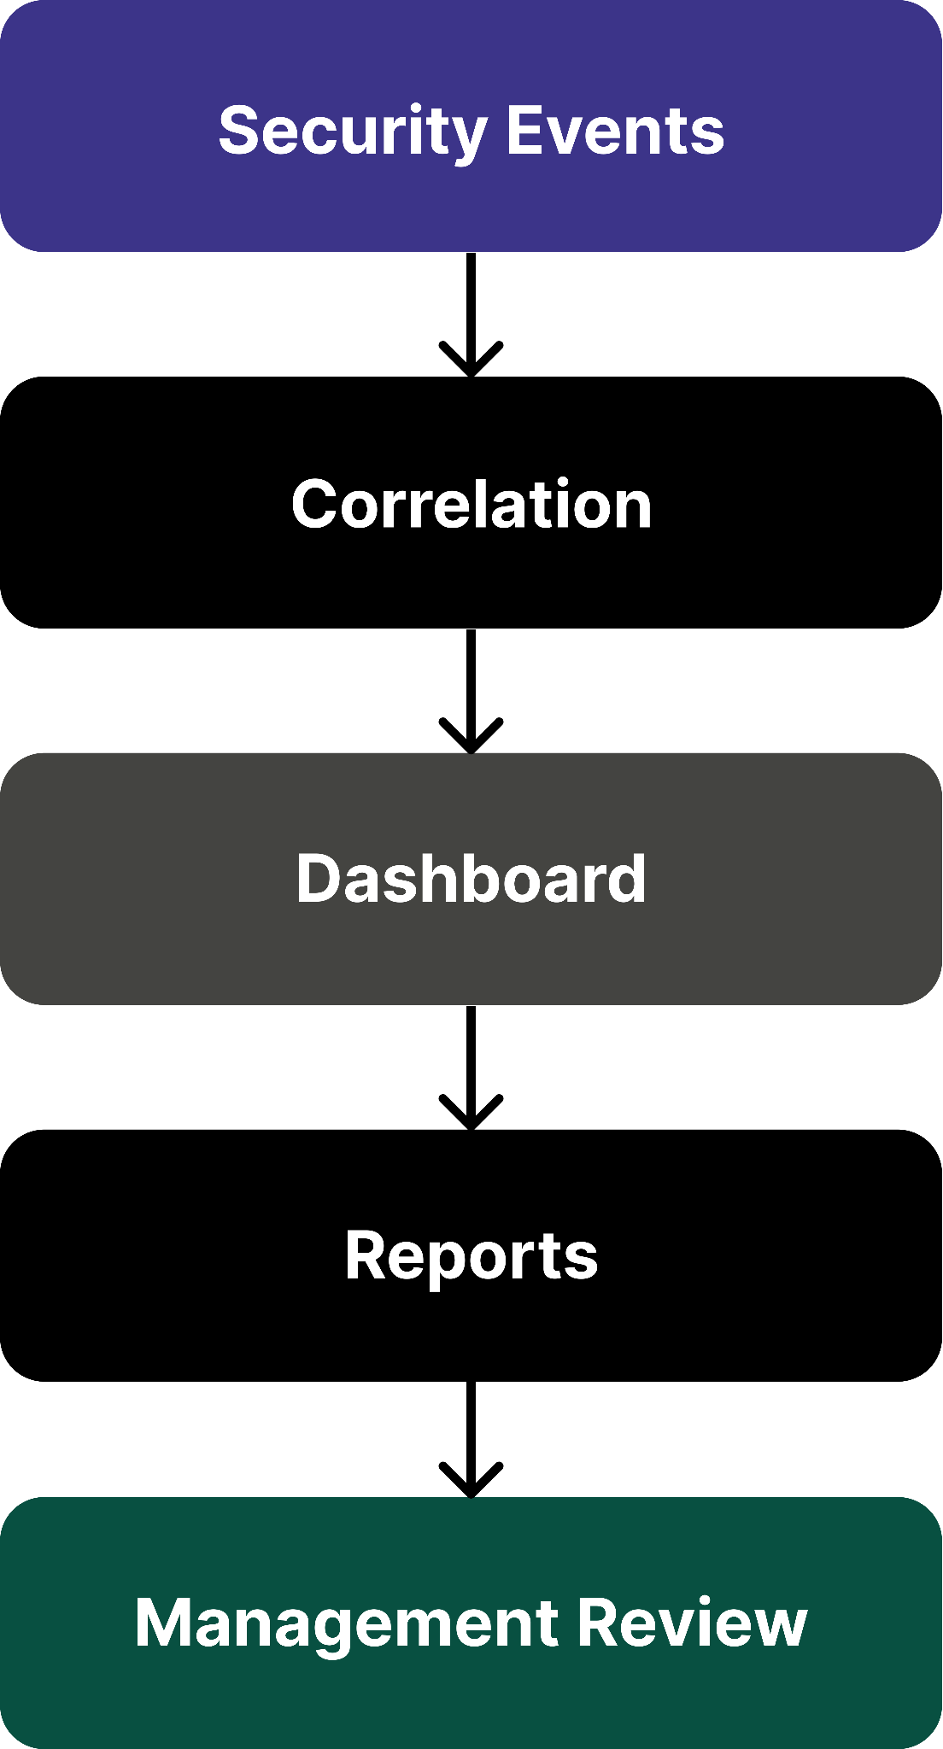

9. Standards Alignment
Standard | Purpose
NIST SP 800-61 Rev.2 | Incident Response
NIST CSF 2.0 | Security Monitoring
ISO/IEC 27035 | Incident Management
MITRE ATT&CK | Threat Classification
OWASP MASVS | Mobile Security Monitoring

10. Conclusion
- This Monitoring & Incident Response Plan establishes a structured approach to detecting, analyzing, responding to, and recovering from security incidents affecting the messaging application.
- The solution combines centralized monitoring through Wazuh, network detection using Suricata, vulnerability assessment with OpenVAS, and standardized incident response procedures based on NIST guidance.
- Continuous monitoring, defined escalation paths, and measurable performance indicators improve operational resilience and reduce the impact of security events.

